Carti Hotel Management System

Use-Case Specification: View Revenue Report

Version <1.0>

Revision History

| **Date** | **Version** | **Description** | **Author** |
| --- | --- | --- | --- |
| 25/Nov/24 | 1.0 | Final Version | Hoang Sinh Hung |
|  |  |  |  |
|  |  |  |  |
|  |  |  |  |

Table of Contents

1. View revenue report 4

1.1 Brief Description 4

2. Flow of Events 4

2.1 Basic Flow 4

3. Special Requirements 5

4. Preconditions 5

4.1 Administrator Authentication Succesful 5

5. Postconditions 5

5.1 Revenue Report Displayed 5

6. Extension Points 5

7. Prototype 6

Use-Case Specification: View Revenue Report

# View revenue report

## Brief Description

This use case allows the administrators to see the daily, weekly, monthly, and annual revenue of the Carti hotel.

# Flow of Events

## Basic Flow

On the Admin Page, a sidebar on the left provides functional buttons such as Home, Category, System, Report, Users, Facility, and Manage Rooms. These buttons allow the admin to navigate through various management functionalities of the hotel.

The main section displays the current status of hotel rooms in a grid format. The room statuses are represented by different colored boxes: blue indicates "Vacant Ready" for rooms available for new guests, light purple shows "Expected Arrival" for rooms reserved for incoming guests, dark blue represents "Stay Over" for rooms occupied by guests staying multiple nights, and grey highlights "Vacant Dirty" for rooms requiring cleaning.

When the admin hovers over the "Reports" button in the sidebar, a dropdown menu appears, listing options such as Revenue Report, Marketing Report, Facility Report, Staff Report, and Customer Report. Clicking on one of these options changes the background color of the selected button, indicating the report currently being accessed.

When the admin clicks on the Revenue Report button, the system redirects to the Revenue Report Page. At the top of this page, four options are displayed as buttons: Daily, Weekly, Monthly, and Yearly reports. These options allow the admin to select the desired type of revenue report. By default, the Monthly Revenue Report is displayed.

When the admin clicks on one of these buttons, its background color changes, visually indicating the selected option. Adjacent to this button is a calendar that enables the admin to select a specific time period for the report they wish to view.

#### **View Daily Revenue Report**

After selecting a specific day, the admin is redirected to the Daily Revenue Report page. This page is displayed as a detailed table with columns such as Date/Time, Item/Dish, Quantity/Unit Sales, Customer Name, and Amount. Each row contains data on individual transactions, allowing the admin to easily review the daily revenue performance.

#### **View Weekly Revenue Report**

Selecting the Weekly Revenue Report button enables the admin to choose a specific week. The system then generates a weekly report presented as a table with seven rows, each summarizing the data of the chosen week.

#### **View Monthly Revenue Report**

Choosing the Monthly Revenue Report button enables the admin to select a specific month. The Monthly Revenue Report page presents a detailed visual representation of lodging revenue by month. The main section features a column chart comparing Lodging Revenue and Occupancy Rate for each month, with distinct colors for each metric. Below the chart, key metrics are summarized: This Month's Revenue with percentage changes from the previous month, Year-to-Date Lodging Revenue, and the Year-to-Date Occupancy Rate, all displayed with visual indicators such as percentage trends and progress circles, providing a clear and concise overview of the hotel's monthly performance..

#### **View Yearly Revenue Report**

If the admin wishes to view the annual revenue report, they click on the Yearly Revenue Report button and select a specific year. The resulting report is displayed as a table containing monthly details for the chosen year, accompanied by a column chart for visualization.

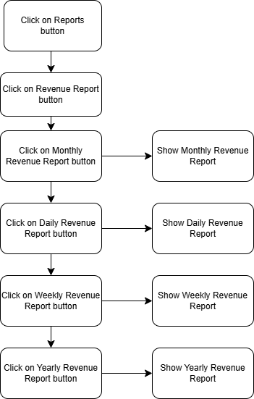

## Alternative Flows

None.

# Special Requirements

None.

# Preconditions

## Administrator Authentication Successful

The user has successfully logged in with the role of administrator.

# Postconditions

## Revenue Report Displayed

The revenue report is successfully displayed on the Administrator Page.

# Extension Point

None.

# Prototype

On the Admin Page, a sidebar on the left provides functional buttons such as Home, Category, System, Report, Users, Facility, and Manage Rooms. These buttons allow the admin to navigate through various management functionalities of the hotel.

The main section displays the current status of hotel rooms in a grid format. The room statuses are represented by different colored boxes: blue indicates "Vacant Ready" for rooms available for new guests, light purple shows "Expected Arrival" for rooms reserved for incoming guests, dark blue represents "Stay Over" for rooms occupied by guests staying multiple nights, and grey highlights "Vacant Dirty" for rooms requiring cleaning.

When the admin hovers over the "Reports" button in the sidebar, a dropdown menu appears, listing options such as Revenue Report, Marketing Report, Facility Report, Staff Report, and Customer Report. Clicking on one of these options changes the background color of the selected button, indicating the report currently being accessed.

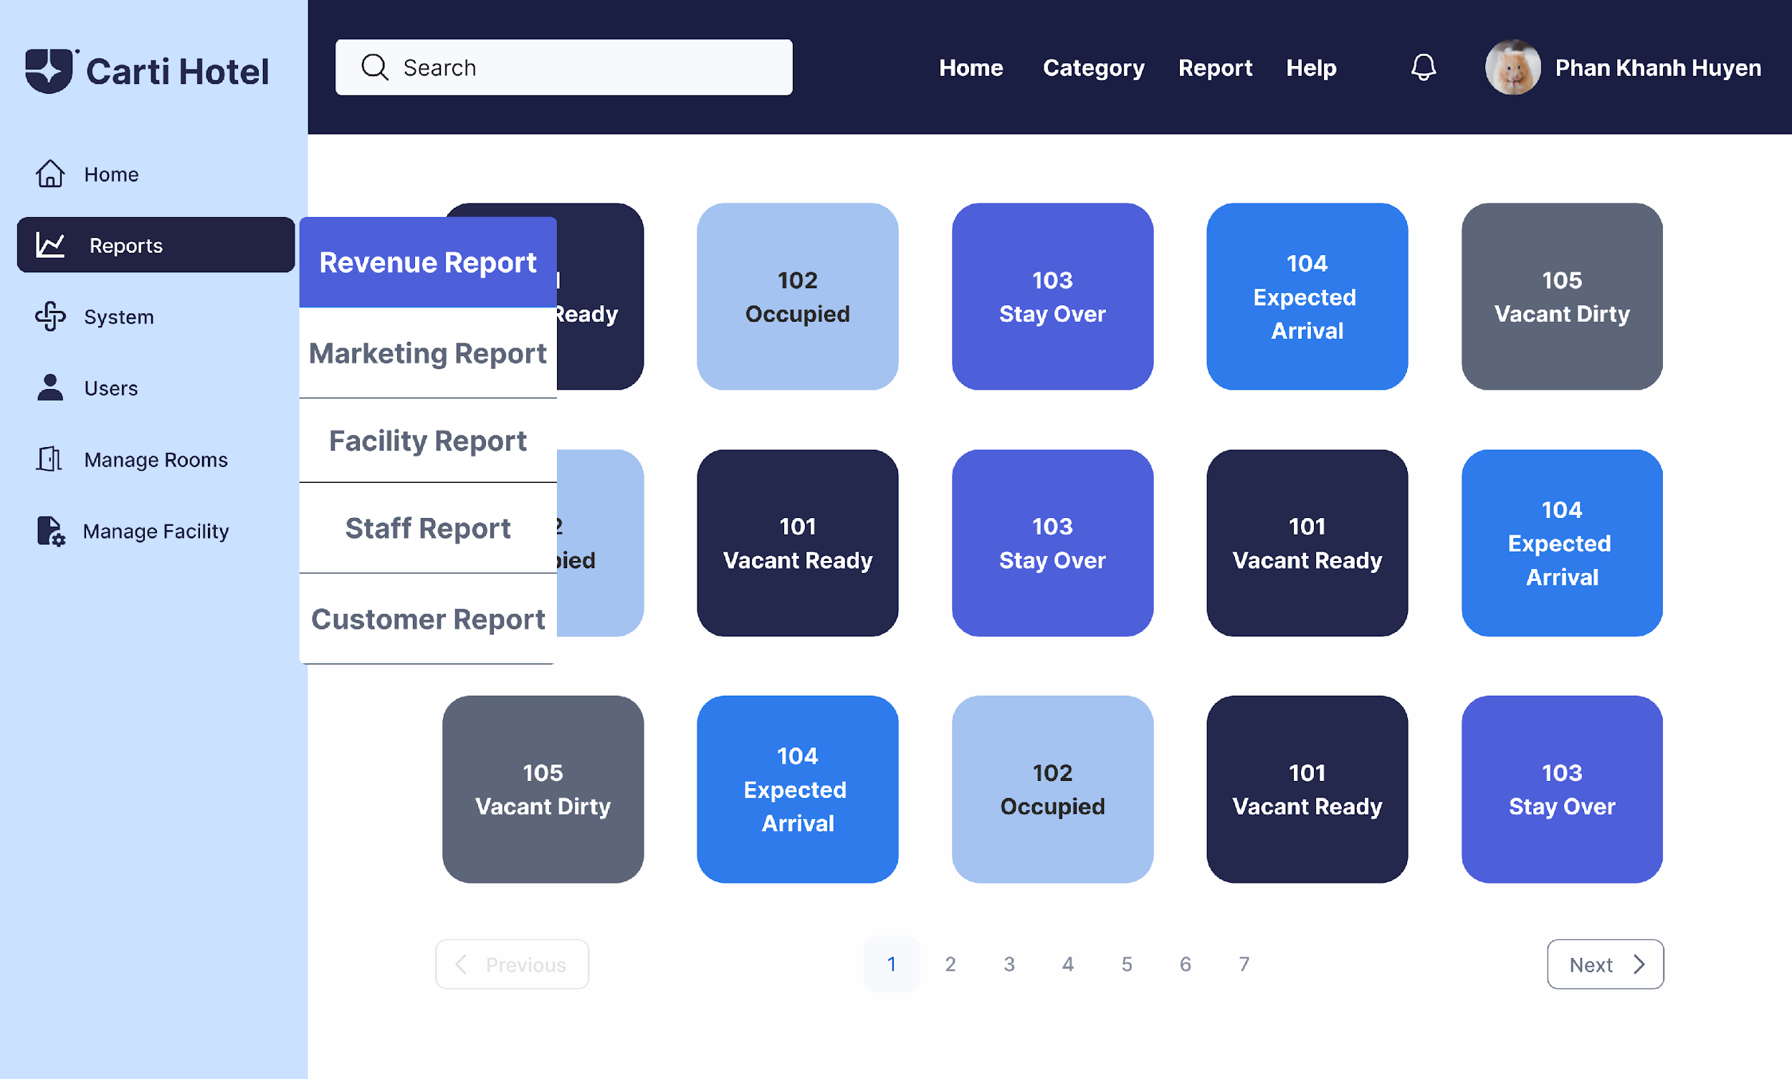

When the admin clicks on the Revenue Report button, the system redirects to the Revenue Report Page. At the top of this page, four options are displayed as buttons: Daily, Weekly, Monthly, and Yearly reports. These options allow the admin to select the desired type of revenue report. By default, the Monthly Revenue Report is displayed.

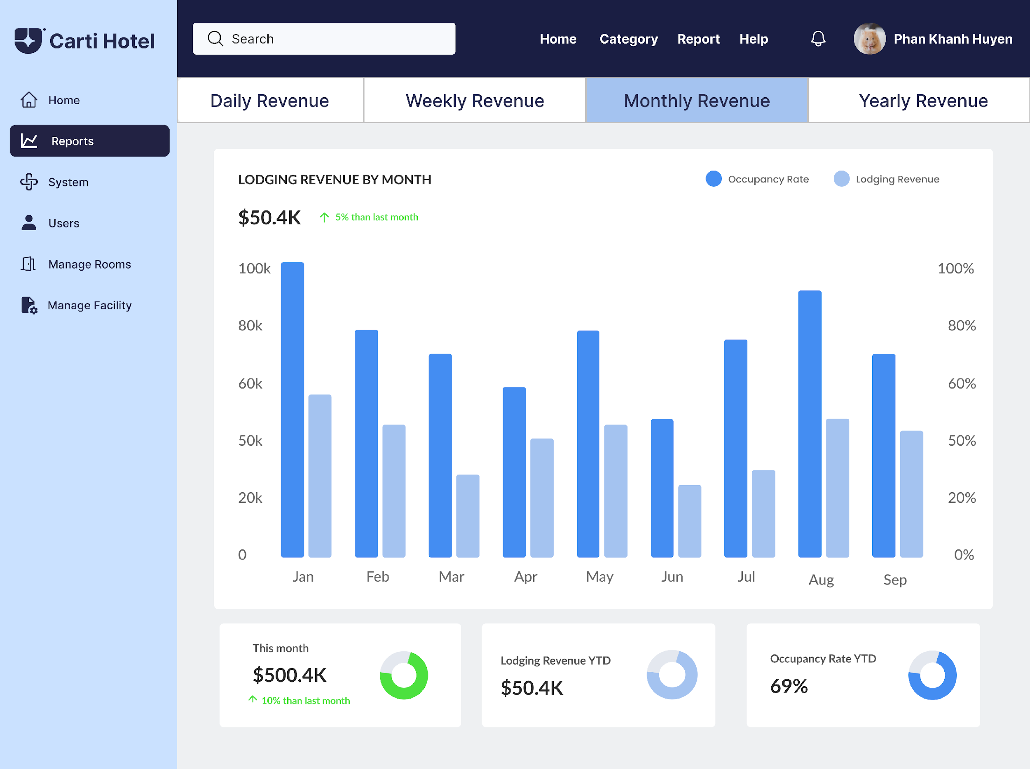

When the admin clicks on one of these buttons, its background color changes, visually indicating the selected option. Adjacent to this button is a calendar that enables the admin to select a specific time period for the report they wish to view.

After selecting a specific day, the admin is redirected to the Daily Revenue Report page.

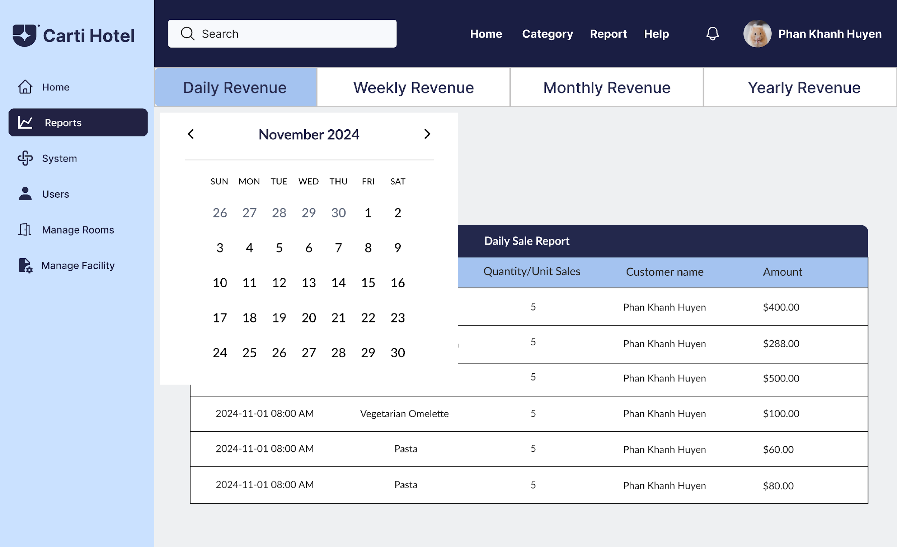

This page is displayed as a detailed table with columns such as Date/Time, Item/Dish, Quantity/Unit Sales, Customer Name, and Amount. Each row contains data on individual transactions, allowing the admin to easily review the daily revenue performance.

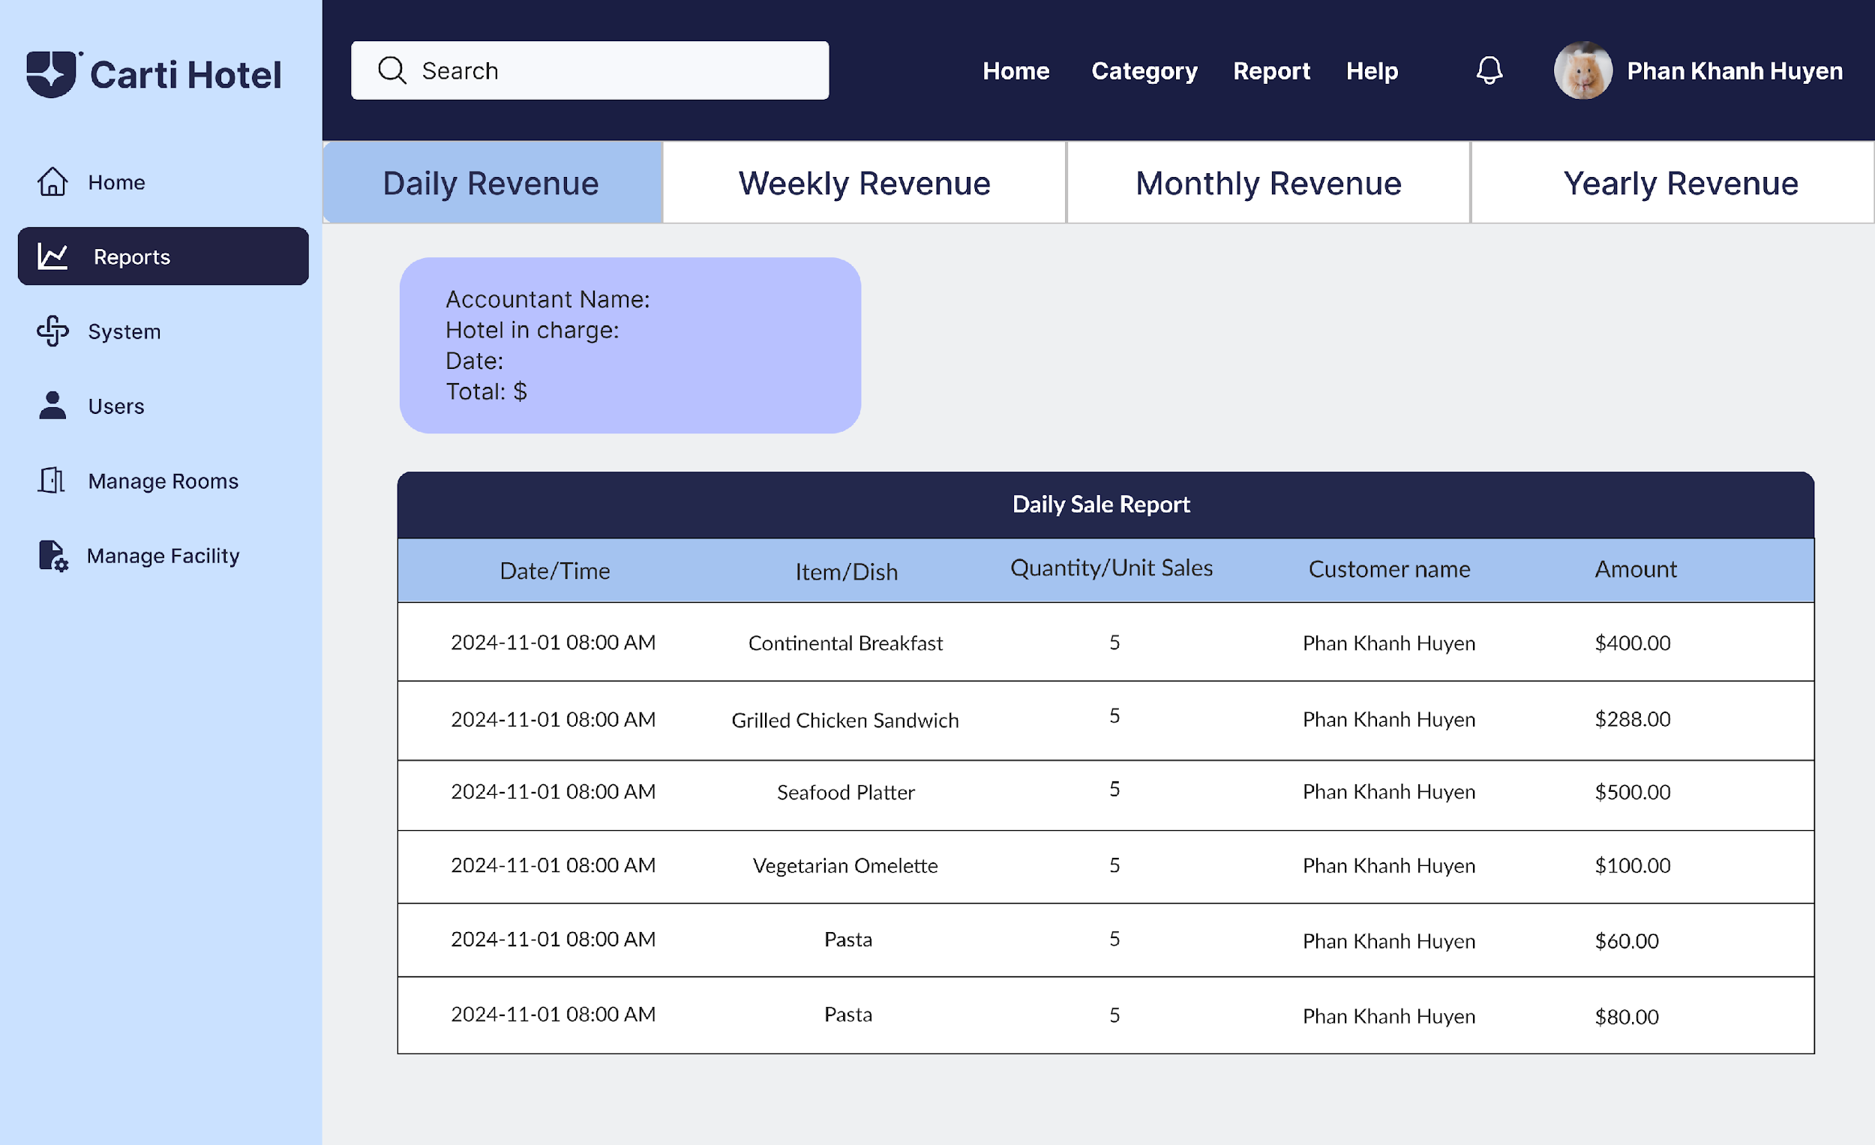

Selecting the Weekly Revenue Report button allows the admin to choose a specific week.

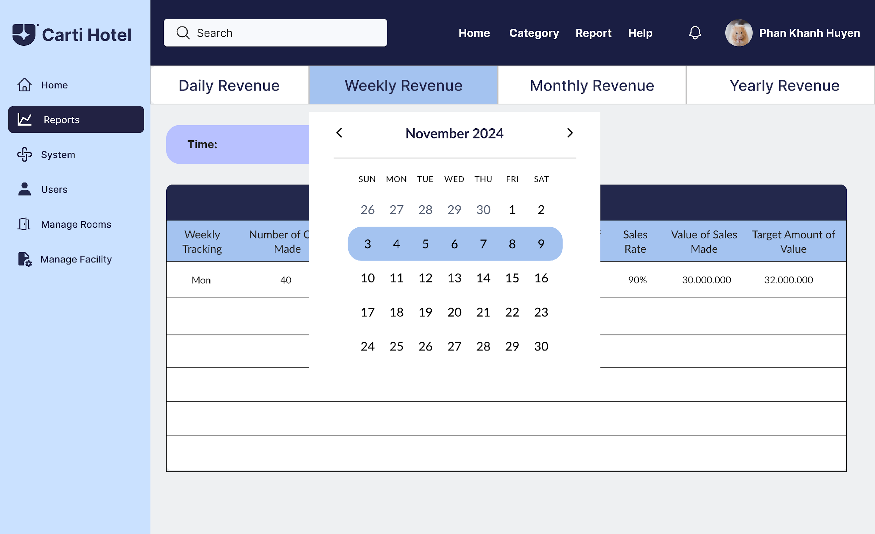

The system generates a weekly report displayed as a table, summarizing data for week from Monday to Sunday.

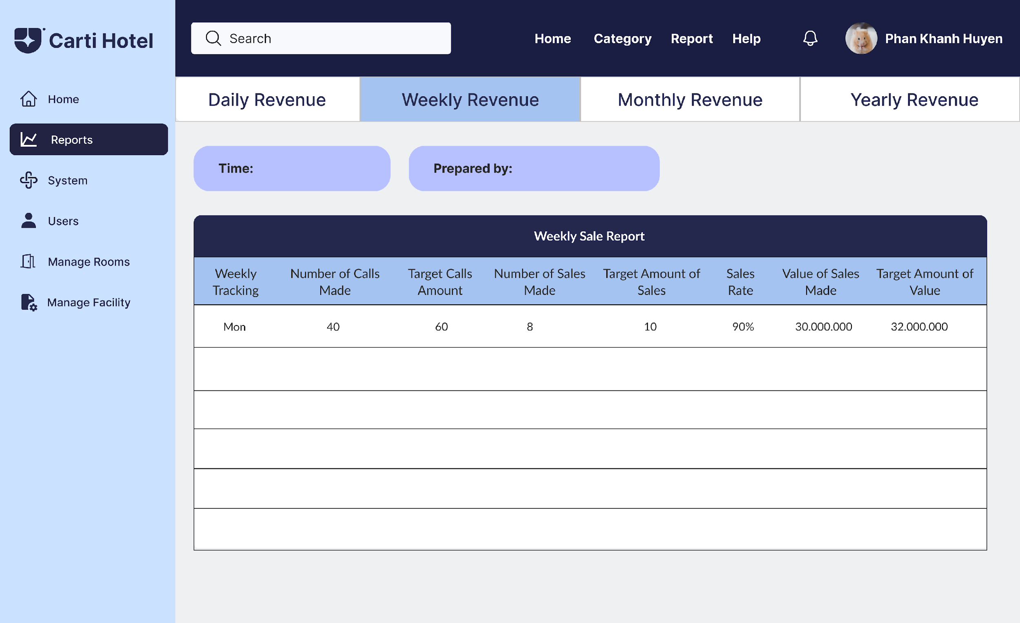

Choosing the Monthly Revenue Report button enables the admin to select a specific month.

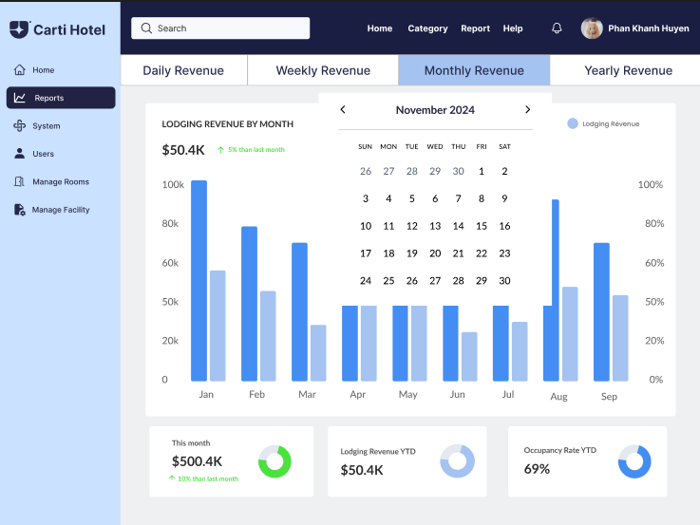

The Monthly Revenue Report page presents a detailed visual representation of lodging revenue by month. The main section features a column chart comparing Lodging Revenue and Occupancy Rate for each month, with distinct colors for each metric. Below the chart, key metrics are summarized: This Month's Revenue with percentage changes from the previous month, Year-to-Date Lodging Revenue, and the Year-to-Date Occupancy Rate, all displayed with visual indicators such as percentage trends and progress circles, providing a clear and concise overview of the hotel's monthly performance.



If the admin wishes to view the annual revenue report, they click on the Yearly Revenue Report button and select a specific year.

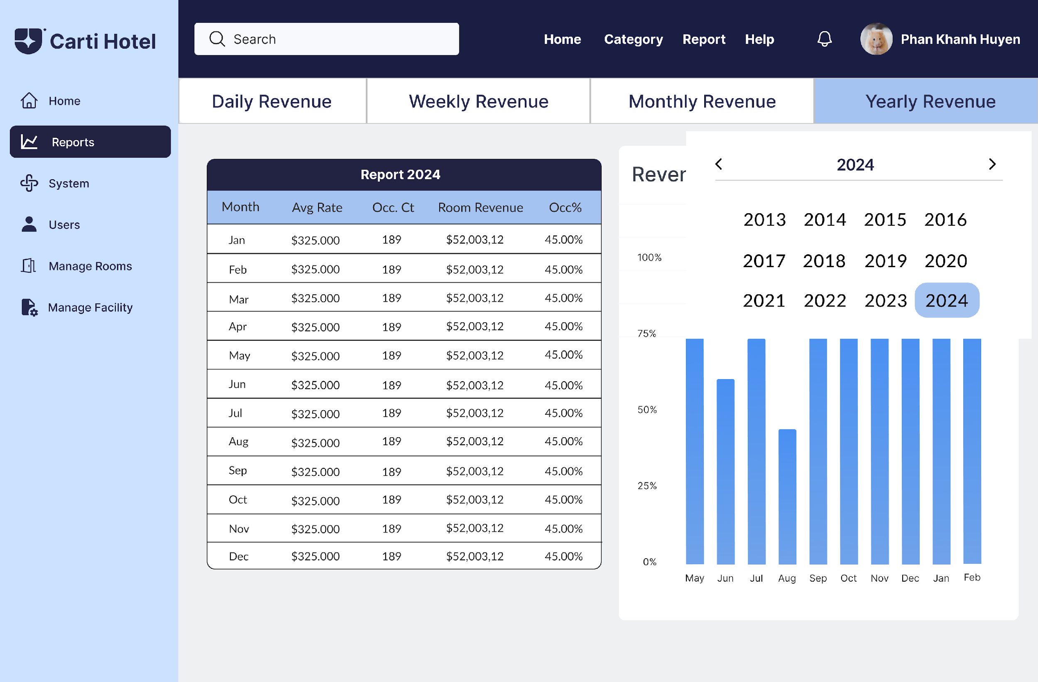

The resulting report is displayed as a table containing monthly details for the chosen year, accompanied by a column chart for visualization.

